This is the original flow chart of the back pain analyzer

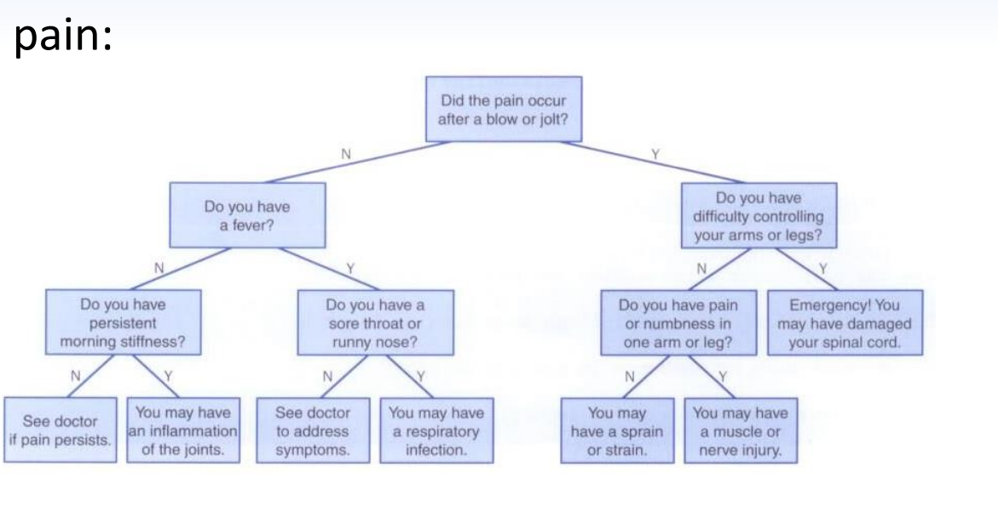

To test my program here are two tests to prove it works.

test#1

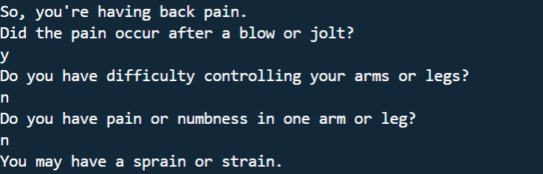

test#2

